CATALOG
Ms. Roberts Beauty Academy
552 North Mannheim Road
Hillside Ill 60162
Euretta C. Ivy
Owner

REV. 12/21
TABLE OF CONTENTS
HISTORY 3
MISSION STATEMENT 3
STAFF…………………………………………………………………….………………………………...3
PHYSICAL DEMANDS 5
SAFETY REQUIREMENTS 5
COMPENSATION 6
EMPLOYER EXPECTATION 6
ACCESS TO RECORDS 6
LICENSING REQUIREMENTS 6
ADMISSION REQUIREMENTS AND FAIR PRACTICE CODE 7
TRANSFER AND RETURNING STUDENTS 7
COURSE OF STUDY………………………………………………………………………….…………9-18
GRADUATION REQUIREMENT 19
PROGRAM LENGTH 19
FACILITY DESCRIPTION 20
TUITION COST………………………………………………………………………………………….18
STUDENTS RIGHTS AND RESPONSIBILITY………………………………………………………………….….…………………19
CANCELLATION POLICY…………………………………………………………………………….20
ATTENDANCE, TARDY AND ILINESS POLICY
LEAVE EARLY, MAKE UP WORK/HOURS, DRESS CODE……………………………….21-22 CODE……………………………………………………………………………..…..………………......21-22
DISTANCE EDUCATION POLICY………………………………………………………………….22-23
ADDITIONAL RULES AND REGULATIONS……………………………………….….……….12-24
SCHOOL SERVICE & SCHOOL CALANDE……………………………………………………...24
INTERNAL COMPLAINT PROCEEDURE……………………………………………………….25
LICENSE AND ACCREDICATION INFORMATION………………………………………...25
LICENSTURE RATE, GRAD RATE AND PLACEMENT RATE………………….……….19&25

PAGE 2

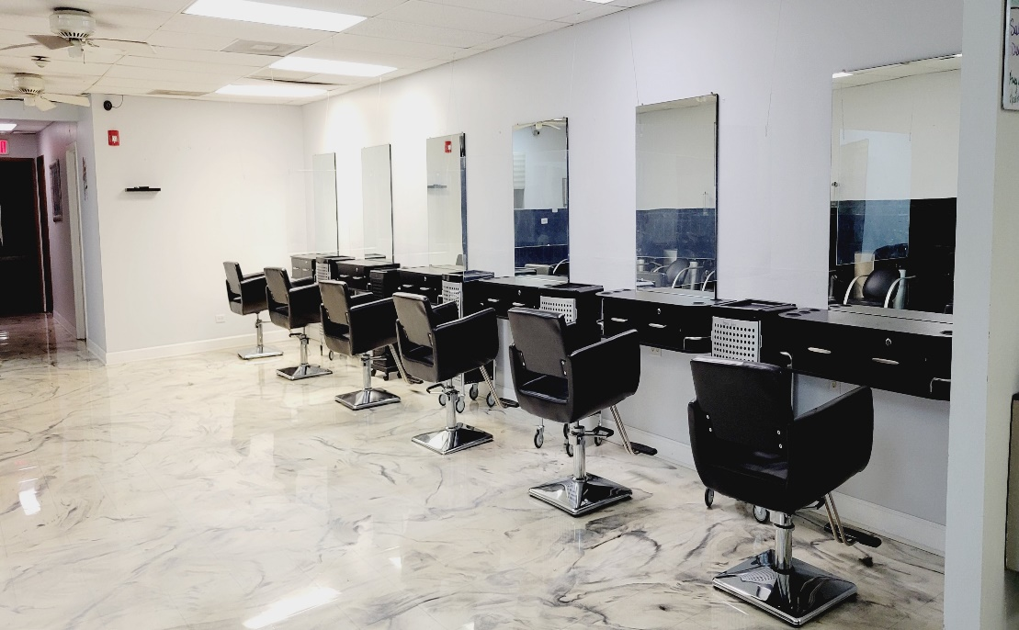
HISTORY
Ms Roberts Beauty Academy was founded in 1960 in Villa Park. Our branch campus, Ms. Roberts Beauty Academy in Hillside Il was opened in 2002. The Villa Park Campus closed in December of 2014.The school’s main objective is to serve the student in achieving the best training possible. Our objective is to produce salon ready graduates and to provide students with a solid foundation of knowledge on which to build a lifelong career.

MISSION STATEMENT
The mission of Ms. Roberts Beauty Academy is to provide excellence in cosmetology education. “Your Education is our Priority” The educational atmosphere is provided by a combination of well-trained staff and well equipped facilities. Provide each student with a strong foundation in all areas of cosmetology, have them graduate, become licensed and employed in the cosmetology field.

OUR STAFF
At MS Roberts Beauty Academy we employ instructors that have worked in/or currently working in our field of study. It is our opinion that if one is not or was not successful in the field, they will have a difficult time teaching students the skills necessary to be successful.

Euretta C. Ivy Owner/Director

Latasha Sims Instructor

Brandon T. Ivy Instructor

Tanika McBee Instructor

Sada Booth Instructor

PAGE 3

WHAT SHOULD YOU EXPECT
Upon completion of our 1500 hour state approved Cosmetology course, 350 hour state approved course in Nail Technology Course and our Nail or Cosmetology Instructors Course each student will be able to demonstrate job entry skills in all required subjects, take and pass a final school examination in both theoretical and practical skills. Completion will qualify you sit for examination to obtain an Illinois Beauty Culture license.

Cosmetology
1500 hours of instruction are required to qualify for examination for and Illinois Cosmetology License. The length of time required to complete depends on course schedule selected. You will be required to complete practical assignments and finals with a 3 or better. We utilize Milady Curriculum and you will be required to complete all test with and 80% or better in addition to a 400-question final.

Cosmetology Instructor 1000 hour and Cosmetology Instructor 500
If you have less than two years as a license cosmetology, 1000 hours of instruction are required to qualify for examination for and Illinois Cosmetology Instructors License. If you have more than two years as a license cosmetology, 500 hours of instruction are required to qualify for examination for and Illinois Beauty Cosmetology Instructors License. The length of time. The length of time required to complete depends on course schedule selected. You will be required to take and past on theory exams with an 80% or better. Prepare lesson plans and Instruct for a minimum of 3 chapters.

Nail Technology Program
350 hours of instruction are required to qualify for examination for and Illinois Beauty Culture License. The length of time required to complete depends on course schedule selected. You will be required to complete practical assignments and finals with a 3 or better. We utilize Milady Curriculum, and you will be required to complete all test with an 80% or better in addition to a 200 question final.

Nail Technology Instructor 625
If you have less than two years as a license cosmetology, 625 hours of instruction are required to qualify for examination for and Illinois Beauty Culture Instructors License. The length of time required to complete depends on course schedule selected. You will be required to complete practical assignments and finals with a 3 or better. We utilize Milady Curriculum and you will be required to complete all test with an 80% or better in addition to a 200-question final

PAGE 4
Upon completion of this course, you will be qualified to take state board and perform a number of competencies with in the field of Nail Technology, Cosmetology and Instruction.

Physical Demands
It is important that prospective students be aware of the physical demands that will be put on them in our profession.
Long hours on your feet, back strain performing such skills as shampooing, pedicures and helping elderly people from their chairs. Cosmetology and Nail Technicians will require extensive arm, wrist and hand movement as well as respiratory problems may arise from inhaling chemical fumes from perms and hair color and Nail chemical. Skin rashes can occur from contact with chemicals used in our industry. Dry and chapped/cracked hands can result from shampooing clients over a period of time
Nail and Cosmetology Instructor may experience some of the same demands, as well as long hours grading papers, test and lesson plans.
In addition, we may be required to have an extreme amount of patience and tolerance with customers/students.

Safety requirements
Cosmetologists’ work with many chemicals and should work in well ventilated area. Some services may necessitate the wearing of a mask and or protective gloves. Cosmetologist, Nail Technician and Instructors may come in contact with harsh chemicals and exposure to body fluids is likely.
It is recommended that you now train in the industry if you have any physical or mental issues that would not allow you to perform all of the necessary skills required to be successful.

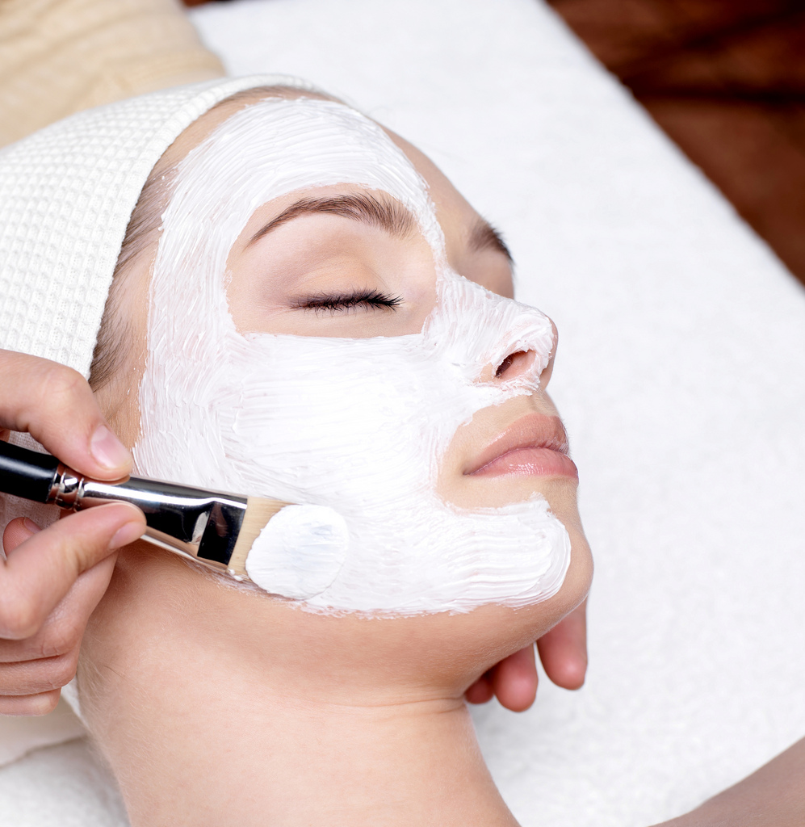

PAGE 5
Compensation:
Cosmetology and Nail Technology Program is a career with many highs and lows within the profession. The 2007 Job Demand Survey (last printed) results as reported by NACCAS indicate that salons in Illinois average annual salary for a salon professional in Illinois are $38,646.00. This amount does not include tips and gratuities. The national average is $35,973. 70% of salons in the state are employer-owned, 13 % are booth rent and 17 % are a combination of both.

Nail Technician Salary (United States)

Women comprise most of the Nail Technicians in the United States. Individuals in this line of work make around $10.04 per hour on average. Lower pay rates hover around $7.83 per hour, and the higher rates verge on $15.56. Geographic location and years of experience each impact pay for this group, with the former having the largest influence. One in seven report receiving medical and dental coverage from their employers and less than 10 percent collect vision insurance. Most Nail Technicians like their work and job satisfaction is high. The figures in this rundown are based on the results of PayScale's salary questionnaire.
Employers Expectations-
To be successful in our industry employers are looking for employees with a strong work ethic, good people skills, punctuality, takes constructive criticism and is a term player.
Access to records policy
The student and/or parent/guardian of a dependent minor will have the right to gain access to his/her files by qualified personnel. The institution will not release information about an individual student without the student’s and/or parent/guardian of dependent minors’ written permission.
Family Educational Rights and Privacy Act of 1974 per pa (tittle S, USC,5726 is a Federal law designed to protect the privacy of a student’s education records. The law applies to all school which receives funds under an applicable program from the US Department of Education.

The FERPA gives certain rights to parents regarding their children’s education records. These right transfer to the student or former student who has reached the age of 18 or is attending any school beyond the high school level. Students and former students to who the rights and have been transferred are called eligible students.

Students or eligible Parents or Students have the right to inspect and review all of the student education records maintained

Licensing Requirements for the State of Illinois
COSMETOLOGY PROGRAM/NAIL TECHNOLOGY PROGRAM
1) Complete 1500 hours of instruction/ 350 of instruction in the nail program
2) 16 years of age, is beyond the compulsory school attendance or
3) High School Diploma or its equivalency
4) A school of cosmetology my recognize up to 1000 hours of Barbering toward a 1500 cosmetology program

PAGE 6
COSMETOLOGY INSTRUCTOR/NAIL INSTRUCTORS
1) 500- and two-years field experience or 1000 hours of instruction
2) 18 years of age, is beyond the compulsory school attendance or
3) High School Diploma or its equivalency
Cosmetology Instructors License. Length of time required to complete depends on course schedule selected.
625 hours of instruction in Nail Technology Instructors 625 Program are required to qualify for examination for an
Illinois Nail Technology Instructors License. Length of time required to complete depends on course schedule selected.

II. ADMISSION REQUIREMENTS
Fair Practice Code -This institution in its admission, instruction and graduation policies, practices no discrimination on basis of sex, color, ethnic origin, race, creed, age, religion, financial status or country or area of origin or residence. Ms Roberts Academy does not recruit students already attending or admitted to another school offering a similar program of study.
- Schedule Enrollment Appointment
- Submit copy of high school diploma from approved high School or G.E.D
- Submit a copy of your Social Security card or immigration card
- Submit copy of stated issued Driver’s License or State ID
- Complete an admissions enrollment application
- Submit $100.00 enrollment fee unless otherwise agreed
- Put a minimum down payment on your kit of $300.00 cosmetology, Nail Technology Program $200.00
8. Sign a completed enrollment contract provided by the admissions representative.
9. Discuss financing options with enrollment advisor
Student under contact with High School District
- Contact your high school liaison
- Once you have completed the admission requirement of your high district
- Complete an enrollment applications with parent contact information

We accept Financial Aid and Student Loans. We also accept MasterCard, visa, American express.
Scholarships are available for tuition balance for those who qualify

TRANSFER STUDENTS
Transfer students will be admitted with previous training on case by case basis. Ms Roberts Academy will accept from an accredited institution up to 750 hours in Cosmetology up to 175 hours for our Nail Technology Program, up to 500 hours for our Cosmetology Instructor’s 1000 hour program, 250 hours in our Cosmetology Instructors 500 hour program and up to 300 hours in our Nail Instructors program. All transfer students will be required to pass each test in our Curriculum with a 80 or better, pass our final written with an 80% or better and our final practical with an 80% or better. Practical work will be prorated in accordance to the hours needed to complete.

PAGE 7

RETURNING STUDENTS
Students may re-enroll within 7 years of their termination or withdrawal to receive full credit for previous hours. Any student that is returning but has not attended beauty school in over 12 months may be required to complete up to 200 hours of basic practical assignments as well as theory.
Students returning to Ms. Roberts up to 11 months will receive maintain all practical and theory grades. Students returning up to 1- 7 years will receive credit for the hours completed however all theory work must be completed. Practical will be prorated basic on hours left to complete.
We will not accept any hours 7 years and beyond. If the student chooses to re-enter they must complete 1500 hours as well as practical /theory requirements.

*we have the right to not accepted transfer student that have previous reoccurring negative relationship with other school such as attendance, grades, or behavior terminations. We will not prejudge any applicant and will consider the circumstance of each student. Timing is based on the first day of attendance

COURSE OF STUDY
COSMETOLOGY

49-week course: Attendance is 35 ½ hours per week,7.5 hours per day 5.5 on Saturday and not less than 21 total hours in any one week. 1500 hours are to be completed 49 weeks from date classes began.
61.5-week course: Attendance is 25 1/2 hours per week, not less than 5 consecutive hours per day. A min 16 hours of attendance in any one week is required, 500 hours are to be completed 61 ½ weeks from date classes began.
75.25-week course: Attendance is 22 hours per week, not less than 3 consecutive hours per day, as scheduled, day or evening. Student will attend not less than a total of 12 hours in any one week. 1500 hours are to be completed 75.25 weeks from date classes began
100-week course: Attendance is 16 ½ hours per week, not less than 3 consecutive hours per day, as scheduled, day or evening. Student will attend not less than a total of 12 hours in any one week. 1500 hours are to be completed 100 weeks from date classes began.
Additional schedules may be available.

The curriculum shall consist of 1500 hours of coordinated theory and practical experience broken down approximately as follows:
a) Basic Training – 150 hours of classroom instruction in general theory and practical application shall be provided that shall include a minimum of the following subject areas:
1) tools and their use
2) shampoo
3) understanding chemicals and use
4) types of hair
5) sanitation
6) hygiene
PAGE 8
7) skin diseases and conditions
8) anatomy and physiology
9) electricity
10) ethics
11) nail technology
12) esthetics
b) Practical Chemical Application/Hair Treatment – 500 hours of instruction, which shall be a combination of classroom instruction and hands on experience, shall be provided in the following subject areas:

1) chemical safety

2) permanent waving

3) hair coloring, tinting and bleaching

4) hair relaxing

5) hair and scalp conditioning

6) shampooing, toning and rinsing

c) Hair Styling/Hair Dressing – 475 hours of instruction in hair styling, which shall be a combination of classroom instruction and hands on experience, shall be provided in the following subject areas

1) cutting

2) thinning

3) shaping

4) trimming

5) application of electrical/mechanical equipment.

6) curling

7) hair treatments

PAGE 9

d) Shop Management, Sanitation and Interpersonal Relations – 200 hours of classroom/distance instruction shall be provided in the following subject areas:

1) labor law

2) workers' compensation

3) client relations

4) bookkeeping

5) marketing and merchandising

6) emergency first aid

7) right-to-know laws

8) pertinent State and local laws and rules

9) business ethics

10) sanitation

11) electrical devices

12) personal grooming and hygiene

Nail Technology Program
12-week course: Attendance is 35 ½ hours per week,7.5 hours per day 5.5 hours on Saturday and not less than 21 total hours in any one week.350 hours are to be completed 11.5 weeks from date classes began.
14.75week course: Attendance is 27 1/2 hours per week, not less than 5 consecutive hours per day. A min 16 hours of attendance in any one week is required, 350 hours are to be completed 12 weeks from date classes began.
18-week course: Attendance is 22 hours per week, not less than 3 consecutive hours per day, as scheduled, day or evening. Student will attend not less than a total of 12 hours in any one week. 350 hours are to be completed 18 weeks from date classes began
23-week course: Attendance is 16 ½ hours per week, not less than 3 consecutive hours per day, as scheduled, day or evening. Student will attend not less than a total of 12 hours in any one week. 350 hours are to be completed 23 weeks from date classes began.

Additional schedules may be available. We alternate Class Times

Page 10

a) Each student will be required to complete a minimum of 350 clock hours of instruction as follows:

1) Basic Training – 50 hours of classroom instruction in general theory practical application (i.e., practicing nail technology on the public) and technical application (e.g., practicing the technical application on mannequin fingers or on the fingers of another student) shall be provided in the following subject areas:

A) History of nail care;
B) Personal hygiene and public health;
C) Professional ethics;
D) Sterilization and disinfection;
E) Bacteriology;
F) Disorders of the nails;
G) OSHA standards relating to material safety data sheets (MSDS) on chemicals;
H) Chemicals and their use; and
I) Technical applications of chemicals.
2) Related concepts – 15 hours of classroom instruction shall be provided in the following subject areas:

A) Cells, metabolism and body systems;
B) Theory of massage; and
C) People skills.

3) Practices and Procedures – 255 hours of instruction, which shall be a instruction and clinical combination of classroom practical application, shall be provided in the following subject areas:

- Fabric procedures;
B) Sculpting procedures;
C) Light cured gels;
D) Machines or apparatus used in nail technology
E) Manicures;
F) Pedicures;
G) Hand, arm and foot massage;
H) Other procedures as they relate to nail technology; and
Product knowledge as it relates to nail technology.

- Business Practices – 30 hours of classroom instruction shall be provided in the following subject areas:
A) The Act and this Part;
B) Management;
C) OSHA standards relating to chemical use; and
D) Workers' Compensation Act.

PAGE 11
5) Ms. Roberts Academy does not participate in the Internship Program as an optional part of the curriculum
b) A nail technology student is not permitted to practice on the public until he/she has successfully completed the 50 hours of general theory and practical application).
COSMETOLOGY INSTRUCTORS 500
500 hour course with over 2 year with license
18.5-week course: Attendance is 35 ½ hours per week,7.5 hours per day 5.5 on Saturday and not less than 21 total hours in any one week. 500 hours are to be completed 18.5 weeks from date classes began.
23.5-week course: Attendance is 27 1/2 hours per week, not less than 5 consecutive hours per day. A min 16 hours of attendance in any one week is required 500 hours are to be 23.5 weeks from date classes began.
27.5-week course: Attendance is 22 hours per week, not less than 3 consecutive hours per day, as scheduled, day or evening. Student will attend not less than a total of 12 hours in any one week. 500 hours are to be completed 27.5weeks from date classes began
35.5-week course: Attendance is 16 ½ hours per week, not less than 3 consecutive hours per day, as scheduled, day or evening. Student will attend not less than a total of 12 hours in any one week. 50 hours are to be completed 35.5 weeks from date classes began.
Additional schedules may be available.
2) 20 hours of Educational Psychology that shall include, but not be limited to, topics in educational objectives, student characteristics and development, the learning process and an evaluation of learning that relates to teaching. These hours shall be waived on behalf of cosmetology teacher students who have completed a course in Educational Psychology at an accredited college or university.

3) 20 hours of Teaching Methods (Theory) that shall include, but not be limited to, topics in individual differences in learning, lesson planning and design, lesson delivery, assessment of learning performance, classroom management, student motivation and classroom climate. These hours shall be waived on behalf of cosmetology teacher students who have completed a course in Teaching Methods-Secondary Level at an accredited college or university.

4) 150 hours of Application of Teaching Methods that include preparation and organization of subject matter to be presented on a unit by unit basis and presentation of subject matter through application of varied methods (lecture, demonstration, testing and assignments). Presentations must provide teaching objectives to be accomplished and correlate theoretical with practical application.

5) 50 hours of Business Methods that include inventory, recordkeeping, interviewing, supplies, the Act and this Part.

6) 260 hours of Student Teaching under the on-site supervision of an Illinois licensed teacher. The student teacher shall present theoretical and practical demonstrations to students in the basic curriculum.

PAGE 12
b) The approved program for a 500 hour Teacher Training Course shall be based on 2 years of practical experience and shall consist of the Teacher Training Curriculum outlined in subsection (a), with the exception of the 500 hours of post-graduate training.
COSMETOLOGY INSTRUCTORS 1000 HOUR
1000 hour course with over 2 year with license/1000 hour course with under 2 years of license
32-week course: Attendance is 37 ½ hours per week,7.5 hours per day and not less than 21 total hours in any one week. 1000 hours are to be completed 32 weeks from date classes began.

36.5week course: Attendance is 27 1/2 hours per week, not less than 5 consecutive hours per day. A min 16 hours of attendance in any one week is required 1000 hours are to be 36.5 weeks from date classes began.

50.5week course: Attendance is 22 hours per week, not less than 3 consecutive hours per day, as scheduled, day or evening. Student will attend not less than a total of 12 hours in any one week. 1000 hours are to be completed 50.5 weeks from date classes began

65.75 week course: Attendance is 16 ½ hours per week, not less than 3 consecutive hours per day, as scheduled, day or evening. Student will attend not less than a total of 12 hours in any one-week 1000 hours are to be completed 65.75 weeks from date classes began.

Additional schedules may be available.

a) Each student training must complete a teacher program that includes a minimum of 1000 clock hours of instruction as follows:

- 500 hours of Post-Graduate School Training that includes all subjects in the basic cosmetology curriculum including theory and practice. Presentation of material must include the concepts that are intended to be taught and the skills to be acquired during the various phases of basic education.

2) 20 hours of Educational Psychology that shall include, but not be limited to, topics in educational objectives, student characteristics and development, the learning process and an evaluation of learning that relates to teaching. These hours shall be waived on behalf of cosmetology teacher students who have completed a course in Educational Psychology at an accredited college or university.

3) 20 hours of Teaching Methods (Theory) that shall include, but not be limited to, topics in individual differences in learning, lesson planning and design, lesson delivery, assessment of learning performance, classroom management, student motivation and classroom climate. These hours shall be waived on behalf of cosmetology teacher students who have completed a course in Teaching Methods-Secondary Level at an accredited college or university.

PAGE 13
4) 150 hours of Application of Teaching Methods that include preparation and organization of subject matter to be presented on a unit by unit basis and presentation of subject matter through application of varied methods (lecture, demonstration, testing and assignments). Presentations must provide teaching
objectives to be accomplished and correlate theoretical with practical application.

5) 50 hours of Business Methods that include inventory, recordkeeping, interviewing, supplies, the Act and this Part.

6) 260 hours of Student Teaching under the on-site supervision of an Illinois licensed teacher. The student teacher shall present theoretical and practical demonstrations to students in the basic curriculum.
b) The approved program for a 500 hour Teacher Training Course shall be based on 2 years of practical experience and shall consist of the Teacher Training Curriculum outlined in subsection (a), with the exception of the 500 hours of post-graduate training.

NAIL TECHNOLOGY INSTRUCTOR COURSE 625
625 hour course with under 2 years of license
19.75week course: Attendance is 37 ½ hours per week,7.5 hours per day and not less than 21 total hours in any one week. 625 hours are to be completed 19.75 weeks from date classes began.
25.5-week course: Attendance is 27 1/2 hours per week, not less than 5 consecutive hours per day. A min 16 hours of attendance in any one week is required 625 hours are to be completed 25.5 weeks from date classes began.

31.5 week course: Attendance is 22 hours per week, not less than 3 consecutive hours per day, as scheduled, day or evening. Student will attend not less than a total of 12 hours in any one week. 625 hours are to be completed 31.5 weeks from date classes began
Page 14
41-week course: Attendance is 16 ½ hours per week, not less than 3 consecutive hours per day, as scheduled, day or evening. Student will attend not less than a total of 12 hours in any one week. 625 hours are to be completed 41 weeks from date classes began.
Additional schedules may be available.
a) Each student intending to complete teacher training must complete a minimum of 625 clock hour of instruction as follows:
1) 125 hours of post-graduate school training that includes all subjects in the basic nail technology curriculum in including theory and practice. Presentation of material must include the concepts that are intended to be taught and the skills to be acquired during the various phases of basic education.
2) 20 hours of Educational Psychology that shall include, but not be limited to, topics in educational objectives, student characteristics and development, the learning process and an evaluation of learning that relates to teaching. These hours shall be waived on behalf of nail technology teacher students who have completed a course in Educational Psychology at an accredited college or university.

PAGE 14

3) 20 hours of Teaching Methods (Theory) that shall include, but not be limited to, topics in individual differences in learning, lesson planning and design, lesson delivery, assessment of learning performance, classroom management, student motivation and classroom climate. These hours shall be waived on behalf of nail technology students who have completed a course in Teaching Methods-Secondary Level at an accredited college or university.
4) 150 hours of Application of Teaching Methods that include: preparation and organization of subject matter to be presented on a unit by unit basis; and presentation of subject matter through application of varied methods (lecture, demonstration, testing and assignments). Presentations must provide teaching objectives to be accomplished and correlate theoretical with practical application.
5) 50 hours of Business Methods that include inventory, recordkeeping, interviewing, supplies, the Act, this Part and the Workers' Compensation Act.
6) 260 hours of Student Teaching under the on-site supervision of an Illinois licensed teacher. The student teacher shall present theoretical and practical demonstrations to students in the basic curriculum.

GRADING AND GRADUATION REQUIREMENTS FOR MS ROBERTS ACADEMY
Students are evaluated in the following areas:
1. Quality of work
2. Quantity of work
3. Co-operation and dependability
4. Work manner and personal appearance
5. Related theory

Theory will be graded according to the following scale:
100-95 = A = Excellent
94-90 = B = Good
89-80 = C = Satisfactory
79-75 = D = Unsatisfactory
74-below = F = Failing
Related theory: A minimum standard of 80% accuracy is required in each subject. Students may take any test twice to improve a grade point average
Practical and laboratory work will be graded as follow
5 = A = Excellent
4 = B = Good
3 = C = Satisfactory
2 = D = Unsatisfactory
1 = F = Failing

Incomplete or absences are entered as a 0 in the grade book. Students are required to make up theory assignments, examination or practical assignment if missed/or failed. These assignments can be made up during school. Test cannot be taken less 3 days apart. All work should be made up as soon as possible and is the responsibility of the student

PAGE 15
GRADUATION REQUIREMENTS AND DIPLOMA
A diploma/transcript is issued to each student who has met the following requirements:
1. Completed 1500 hours of Cosmetology, 350 hours Nail Technology, 1000 or 500 Cosmetology Instructors, 625 of Nail Technology Instructors.
2. Maintained not less than 80% average on all required written examinations.
3. Completed all practical goals
4. Taken and pass all written and practical finals with and 80%
Or better
5. Retired all financial obligations to the school unless otherwise agreed in writing
PROGRAM LENGTH
COSMETOLOGY
1500 HOURS CAN BE COMPLETED IN 49 weeks, 61.5 weeks 75.25 weeks
100 weeks
CONTRACTUAL GRACE PERIOD
NAIL TECHNOLOGY PROGRAM
350 HOUR PROGRAM CAN BE COMPLETED IN 11.5 WEEKS,
14.75 WEEKS, 18.00 WEEKS OR 23 WEEKS
COSMETOLOGY INSTRUCTORS 1000 HOUR
IS A 1000 HOURS AND CAN BE COMPLETE IN 32 WEEKS,
36.5 WEEKS, 50.5WEEKS, 65.75 WEEKS
COSMETOLOGY INSTRUCTORS 500
IS A 500 HOURS AND CAN BE COMPLETE IN 18.5 WEEKS,
23.5WEEKS, 27.5 WEEKS,35.5 WEEKS

NAIL TECHNOLOGY 625 INSTRUCTORS PROGRAM
IS A 625 HOUR PROGRAM AND CAN BE COMPLETED IN
19.75 WEEKS, 25.5 WEEKS, 31.5 WEEKS, 41 WEEKS
All students are required to complete the program on time, however when that is not possible addition fees may be incurred in accordance to your contract agreement.
Students that do not complete the hours as stated in your contract do not have a grace period. Any hours not completed at the end of the contract will be charge at a rate of $10.00 per hour to complete and must be paid in advance at the last day of the contract unless previously arranged in writing.
Students have a grace period of 1 month after the contract end date to complete all Practical and Written requirement. An additional fee of $10.00 per hour may be charged for all Practical and Written requirements. An additional fee of $10.00 per hour may be charged for all Practical and Written requirement taken after the 1 month period. There will also be a 50.00 fee to take the Final Practical Exam after the 1 month grace period.

Ms Roberts Academy will process the paper work to register each student for the state board once they have completed the above requirements for an additional fee of $50.00
In addition, to take their state board exam they will need a copy of current driver’s licenses. The cost of the state exam is the student responsibility. Current cost $180.00 (change without notice)

Ms Roberts does aid students in seeking employment. Students desiring assistance with job placement need to notify the school office that such assistance is needed. The school cannot, and does not guarantee job placement but will make every effort to assist each student in locating a position in the career they have chosen.
PAGE 16
FACILITY DESCRIPTION
Ms Roberts Academy offers large, well equipped classrooms, locker facilities, student lounge and large spacious clinic area for practical experience.
Ms Roberts Hillside is a well-equipped location with 2 clinic floors, 3 spacious classroom areas. We have recently updated our facility is conveniently located near public transportation Pace 310 Pace 313 & 317 with I290 & I294 express exits.
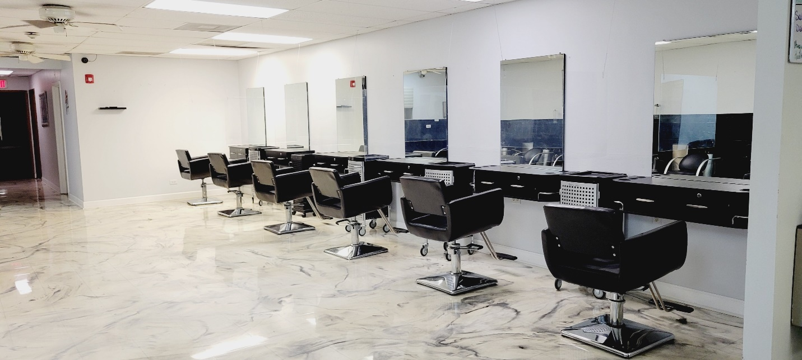
TUITION COST
COSMETOLOGY 1500 HOUR PROGRAM
Enrollment Fee…………………………………………………. $100.00 (if not waived)January
Kit, Books, Uniform…………………………………………... $ 1,400.00
Tuition…………………………….…………………………….... $18,900.00
Total Cost……………………………………………………….… $20,400.00
Scholarships/and payment plans are available to those who qualify
NAIL TECHNOLOGY 350 HOUR PROGRAM
Enrollment Fee…………………………………………………. $100.00 (if not waived)
Kit, Books, Uniform………….………………………………. $800.00
Tuition……………………………………………….……………. $2500.00
Total Program cost………………………….………….…… $3400.00
Scholarships/and payment plans are available to those who qualify
NAIL INSTRUCTORS 625 HOUR PROGRAM
Enrollment Fee…………….……………………………………. $100.00
Books, Uniform………….……………………………….……. $200.00
Tuition……………………….……………………………………… $4000.00
Total Program Cost……………………………………………. $4300.00
Scholarships/and payment plans are available to those who qualify
COSMETOLOGY INSTRUCTORS 1000 HOUR PROGRAM
Enrollment Fee……...……………………………………………. $100.00 if not waived
Books, Uniform………….……………………………….……… $400.00
Tuition………………….……………………….……………………. $7000.00
Total Program Cost Fee………………………………………. $7500.00
PAGE 17

COSMETOLOGY INSTRUCTORS 500 HOUR PROGRAM 625 HOURS
Enrollment Fee……………………………………………………. $100.00 if not waived
Books, Uniform………….……………………………….……. $400.00
Tuition………………………………………….……………………. $6000.00
Total Program Cost……………………………………………… $6400.00
Scholarships/and payment plans are available to those who qualify

Each student is responsible for the state board fee $185.00 (subject to change), and $50 graduation fee per signed contract.
Additional Cost: Each student is responsible for their own classroom and clinic products and supplies. The only items supply by the institution is chemicals, shampoo and conditioner used on paying clients.

Payment plans are prearranged prior to start day and all payment arrangements are list on the contract and agreed to by both parties. Method of payment accepted would be cash, MasterCard, visa and money orders
Scholarships are available for students that successful complete the program with 90% GPA and 90% attendance. The highest amount that can be awarded for one year is $5000
All fees will be paid unless other arrangements are made do to circumstance
COMPLETION RATES
The placement rate represents students who completed the cosmetology program between January 1, 2018 and December 31, 2018 and were employed by November 20, 2019.
COMPLETION 61.5%
PLACEMENT 87.5%
LICENSURE 83 %

STUDENTS’S FINANCIAL AID RIGHTS AND RESPONSIBILITIESSTUDENTS RIGHTS INCLUDE:
• Knowledge of the cost of the program chosen at Ms Roberts Academy
• Understanding what criteria Ms Roberts Academy uses to award student financial aid
• Knowledge of the types of financial assistance that is available. Including information private, and institutional financial aid programs
• Criteria for meeting satisfactory academic progress and maintaining financial eligibility
• The current interest rate of any loan accepted and repayment terms of the loan
• The total amount of student loans borrowed that will need to be repaid prior to attending
STUDENT RESPONSIBILITIES INCLUDED:
• Complete all finance forms
• Provided additional documentation requested by Ms Roberts Academy in order to complete verification or resolve discrepancies
• Maintaining Satisfactory Academic Progress in attendance, theory and practical in order to remain eligible to receive financial assistance
• Repay all loans
• Have a thorough understanding of all documents signed
Family educational rights and privacy act (FERPA) The Family Educational Rights and Privacy Act of 1974 PERPA) (Title 37, USC, Section 406 and Title 5, USC, 5726) is a Federal law designed to protect the
PAGE 18

privacy of a student’s education records. The law applies to all school which receives funds under an applicable program from the US Department of Education.
The FERPA gives certain rights to parts regarding their children’s education records. These rights transfer to the student or former student who has reached the age of 18 or is attending any school beyond the high school level. Students and former students to who the rights have been transferred are called eligible students.
Students, Eligible Parents or eligible students have the right to inspect and review all of the student’s education records maintained by the school. The Schools are not required to provide copies of materials in education records unless, for reasons such as great distance, it is impossible for parents or eligible students to inspect the records personally. The school may charge a fee for copies.
CANCELLATION AND REFUND POLICY
1. If a student (or in case of a student under legal age, his/her parent or guardian) cancels hi/her enrollment and demands his/her money back, in writing or in person, within 5 business days of the signing of an enrollment agreement or contract, and prior to entering classes, all monies collected by the school shall be refunded. The cancellation date will be determined by a postmark on written notification, or the date said information is delivered to the school administrator/owner in person. This policy applies regardless of whether or the student has actually started training,
2. If a student cancels his/her enrollment after 5 business days after signing but prior to entering class. He/she shall be entitled to a refund of all monies paid to the school less a registration fee of $100.00 if paid and not waived
3. For students who enroll in and begin classes the following schedule of tuition adjustment is authorized:
Percentage of Actual Time Completed | Amount of Total Tuition Owed to Ms. Roberts Beauty Academy
0.01%-4.9% | 10%
5%-9.9% | 30%
10%-14.9% | 40%
15%-24.9% | 45%
25%-49.9% | 70%
50% and over | 100%
T
Enrollment Time is defined as the time elapsed between the actual starting date and the date of the students last day of physical attendance in the school. Termination shall occur upon students last day of physical attendance in the school. Any monies due the applicant or students shall be refunded with 30 days of formal cancellation my the student as defined in item 1, or formal termination by the school which shall occur no more than 30 days from the last day of physical attendance, or in the case of the a leave of absence the documented day of return

4. The cost of any extra items required by the students, such as instructional supplies, or equipment, service charges, student’s activity fees, deposits, rentals, and other miscellaneous charges, are not considered in the Enrollment Agreement. The school catalog, or in other information furnished to the student/applicant before enrollment purchased at the school in full. By the student/applicant at the time of receipt of such supplies. There will be no refund for any of these items.
5. An applicant rejected by the institution shall be entitled to a refund all monies paid
6. If a school is permanently closed and no longer has offering instruction after a student enrolled the student shall be entitled to a prorated refund of tuition
7. If a course is cancelled subsequent to a student’s enrollment, the school shall at its option to:
a. Provide a full refund of all monies paid or
b. Provided completion of the course
Cancellation or termination by student:

PAGE 19
A Student my cancel or terminated enrollment by notifying this school of this or her intentions in writing.

ATTENDNACE
1. Punch in and out when arriving and leaving the building for any reason.
2. Students my not attend more than 40 hours per week. Except in hardship cases, and with permission.
3. Student may attend a maximum of 8 hours by not less than 3 consecutive hours per day except in hardship cases and with permission. Students attending 6 or more consecutive hours shall take a ½ hour lunch. If you do not punch out for lunch the system will assume 1 hour.
4. Evening classes are for night students: day students my not attend except with special permission. Mondays are for the High School Program and no adult student may attend on Monday without permission
5. Student absent, without notice, for a period of more than 14 days will be dropped without further notice.
6. Students are required to maintain total number of hours per month according to their enrollment agreement. Students not maintaining their schedule will be changed to another schedule or dropped depending on seriousness of situation
7. Students are expected to call when absent
8. Students who temporarily withdraw from the program will be allowed to return. A student making satisfactory will keep that status. Students failing to meet minimum requirements at the point of withdrawal will be placed on probation for one month. The student will be reevaluated in accordance to our satisfactory progress policy.
9. Students are not allowed to miss more than 1 Saturday per month without penalty. Or be late more than one Saturday per month without penalty. The Students that are not required to attend Saturday Friday will be considered there Saturday
10. Consequence for Missing Saturday is suspension the following business day. Director will review special circumstances
11. Students may not miss the day before or after the Holiday unless it is prearranged
12. Consequences for missing the day before or the day after the holiday will be 1 day suspension.

TARDINESS
Students are expected to arrive at the beauty school on time. School starts at 8:30a, 11am or 500pm. Depending on which schedule you have chosen. Each student is given a 15min grace period to attend class however they are still considered tardy.
Excessive tardiness could affect you contract and cause you to be over your contract completion date. Your over contract amount is $10 per hour
ILLINESS
Each student is given 2 weeks of absences in case of Illinois. Student with excessive or prolonged absences will require a doctor’s note. In the case of prolong illness the student should elect to take a leave of absence.
LEAVING EARLY
Students are required to complete a full day in accordance with their contract. However we do understand that there are circumstances which require a student to leave for the day.
In these circumstances a student will be allowed to leave, however there can be no more that 3 leave early request. If a student leaves early more the 3 times student will not be allow to make up hours.
MAKE UP HOURS/MISSED WORK
Hours missed are made up only at clinic times when clients and must be approved by the Director
All missed work must be made up and it is the responsibility of the student to find out what work is required and to make it up in a timely minor.

PAGE 20

DRESS CODE
1. Students are to wear a professional uniforms supplied in kit
2. All other attire must be in black /or White no other visible colors permitted
3. Socks or nylon hose always for safety
4. Makeup, hair and nails should be well groomed and manicured

DRUG FREE SCHOOL AND WORKPLACE INFORMATION
Alcoholic beverages are not allowed in any form at the School, and any student or employee that consumes alcoholic beverages immediately prior to coming to the school, will be suspended from training. The same rule applies to the use of marijuana and nonprescription drugs. Ms. Roberts has a no tolerance policy in regards to Alcoholic Beverages and Nonprescription Drugs.
All students receive a copy of our handbook on the first day of class and in effect acknowledge the awareness of our Drug and Alcohol Free environment.
Drug Free School and Workplace Statement
PAGE 21

LEAVE OF ABSENCE POLICY:

The Director must approve all request for leave of absence. All request must be in submitted in advance in writing to the Director. No verbal request will be accepted unless a unforeseen circumstance prevent the student from complying with the regulation. The student can only take 2 leaves inside of a contract, my not exceed 180 combined and may not be less than 2 weeks. An equal amount of days will be added to extend the contract.
A student returning from leave or other official interruption of training must return to school I the same satisfactory progress as prior to their departure

1. Ms Roberts Academy (hereinafter referred to as “this institution” has a policy of maintaining a Drug Free Workplace and School. All students and employees are hereby notified that the unlawful manufacture, distribution, dispensing, possession or use of a controlled substance is prohibited in the institution’s workplace. The workplace for this institution is defined in paragraph 2
2. In compliance with the Drug Free Workplace act of 1988, this institutions workplace consists of the following locations:
a. The entire campus facility
b. Any location used as an offsite school function i.e. competition, hair show etc.
c. Students and employees must comply with the policy while off site if they are in service of the institution in any capacity.
3. Noncompliance with the terms in Paragraph 1 will result in the following action being taken by this institution.
a. Mandatory counseling, rehabilitation given by a Federal, State or Local Health, law enforcement, or other appropriate agency which is approved for purposes of chemical abuse counseling and rehabilitation or
b. Termination of enrollment, or employment, whichever is applicable, as well as referral for prosecution for violation of the standards of conduct.
4. All students and employees must read and understand the following statement

PAGE 22

5. The student participates in learning activities while physically present at the contracted campus at least once every 10 business days for the length of a scheduled class day as outlined in the enrollment contract
6. All transcripts or other documents, (official or unofficial), will list hours that where obtained in distance learning separately.
NOTE: Academic achievement earned via distance education may not be accepted for reciprocity or eligible for licensure in other states
RULES AND REGULATIONS
ALL OF OUR RULES ARE IN OUR HANDBOOK WHICH WE REVIEW DURING ORENITATION. AT THE DISCRETION OF THE SCHOOL, THESE RULES MAY BE CHANGED FROM TIME TO TIME, AND SHALL BECOME EFFECTIVE WHEN POSED ON THE BULLETIN BOARD
GENERAL
- Smoking, gum chewing, eating or drinking is not allowed in the
Classroom clinic, or clinic reception areas
- Personal telephone calls will be accepted only in an emergency. Cell phones are allowed on the clinic floor or classrooms
- Students receiving a service must first get permission from the instructor in charge
- A nominal charge will be made for supplies used for student services
- Kits and implement are to be cleaned and sanitized daily; inadequate or dirty equipment will be cause for dismissal for the day
- Sanitation assignments are to be completed daily.
- All student must purchase finishing products used on clients
- Cheating, stealing or forging an instructions name will be considered cause for dismissal.
- Clinic customers may request for a particular student by name for an additional fee. Cannot requested based on skill/race or ethnic background
- Any loss or breakage of the student’s equipment must be replaced at the student expense.
11. All supplies and equipment will be discarded/sold if left more than 30 days. Students on leave for more than 30 days must take all their belonging with them. We are not responsible for item left on the premise
STUDENT SERVICES
- Counseling
- Instructional Staff:
- All instructors are licensed by the state of Illinois and have
Been or is currently working in the Industry.
Aids students to improve learning skills, prepare for examination, and establish working relationships with other students, customers and staff.
C. Management:
Aids the students in selecting schedules of attendance and suitable financial arrangements
- Administrative Assistant
Aid student in job placement, daily attendance, and leaves of absents
PAGE 23

- Housing:
- Students arrange for own housing

- Parking and transportation
Parking is free in mall lot and is conveniently located near public transportation Pace 310 Pace 313 & 317 with I290 & I294 express exits.
- Ms Roberts Beauty Academy is committed to assist every graduate who seeks employment in the beauty industry however we do not guarantee employment.
SCHOOL CALENDAR
Classes began the 2nd week of every month unless a holiday/weather days interfere interferes
School hours are:
Monday: High School under training agreement only 12pm to 5:30P
Tuesday: 8:30m to 4:30pm
Wednesday: 8:30am to 9:30pm
Thursday: 8:30am to 9:30pm
Friday : 8:30am to 4:30pm
Saturday: 8:30am to 2:00pm
The school are closed on the following holidays:
New Year’s Day, July 4 week, Thanksgiving weekend, Christmas Eve thru New Years Day. All snow days as designated by district.

CAMPUS SECURITY REPORT:
As required by the Clergy act, each university or college must publish and make available to student’s interested students, staff, and the general public it annual crime report. Ms. Roberts Academy has collected data filed its report for the year calendar year ending 12-31-2019. A full copy of the report is available in the school office or online
TIMELY WARNING
If a situation arises, either on or off campus, that, in the judgment of the school president or staff, constitutes an ongoing or continuing threat, a campus wide timely warning will be issued. The warning will be issued through the academy bulletin boards by general announcement or by email/ text messages. Anyone with information warranting a time warning should report the circumstances to the school office in person at the school in 552 North Mannheim Road Hillside IL.

INTERNAL COMPLANT PROCEDURE
Students or staff having problems or complaints against the school should first put it in writing and them given to the school owner. School owner will meet with the complainant within 10 days of receipt of the written complaint. If after careful evaluation the problem cannot be resolved through discussion the complaint will be referred to the schools’ complaint committee. All meetings will document and give a copy to all parties. The committee will meet within 21 days of receipt of the complaint and review the allegations. If more information is needed from the complainant a letter will be written outlining the additional information. The committee will act on the allegations within 15 days stating the steps taken to correct the problem or show that the allegations

PAGE 24

OCCUPATIONAL INFORMATION NETWORK
O’Net is the nation’s primary source for occupational information and a tool to search potential career options and obtain valuable information about numerous occupations. You may visit O’Net at http://www.onetonline.org./crosswalk/enter the Classification of Instructional Programs code (CIP) #120401 under education menu tab for more information related to the program.
we are not warranted or based on fact. Every effort should be made by the complaint to resolve the problem through the school. If at this point the complaint is still not satisfied with the schools

STANDARD OCCUPATIONAL CLASSIFICATIONS
A Standard occupational Classification or SOC code is a number that represents an occupational classification which links a occupation.
The following SOC codes are related to cosmetology:
SOC code: 39-5012.00 Cosmetology
SOC code: 39-5092 Nail Technology
SOC code: 12.0413 COSMETOLOGY INSTRUCTORS
CODE OF CONDUCT POLICY schools receiving FAFSA
The higher education opportunity act adds once receive funding
COMPLETION RATES
The placement rate represents students who completed the cosmetology program between January 1, 2020 and December 31, 2020 and were employed by November 30, 2021.
COMPLETION 61.5%
PLACEMENT 87.5%
LICENSURE 83%

Accreditation
National Accrediting Commission of Career Arts & Sciences (NACCAS)
3015 Colvin Street Suite 1300, Alexandria VA 22314 #023191-00
Curriculum
Milady Standard Cosmetology Book, Cengage online learning platform theory workbook, Essential companion for std cos 2012 and web pac cmw/
ISBN#9781285482279 cost $250.00
State License
The Illinois Department of Professional Regulation 320 W. Washington 3rd floor, Springfield IL 62786. Phone #217-782-8556.05012017rev

PAGE 25

